SLE-3: Architectural Design (Full C4 Model)
Course: 02AML204 – Introduction to Artificial Intelligence
PRN | 25UAM061
Name | Atharv Deepak Shinde
Division | A
Date | 04/10/2026
GitHub Link | https://github.com/athyashinde07-byte/SLE2-BFS-vs-DFS-Profiling
1. System Title & Short Description
BFS vs DFS Grid Search Profiling System
This system continues my SLE-2 work. It runs Breadth-First Search (BFS) and Depth-First Search (DFS) on a 40 x 40 open grid (start node 0, goal node 1599) and profiles both. For each algorithm it measures average runtime (using Python timeit, 5 batches x 100 repetitions) and the number of nodes expanded. The problem it solves is empirical comparison: instead of only quoting theory, it produces measured data showing how the two search strategies behave on the same problem.
2. Context Diagram (Level 1)
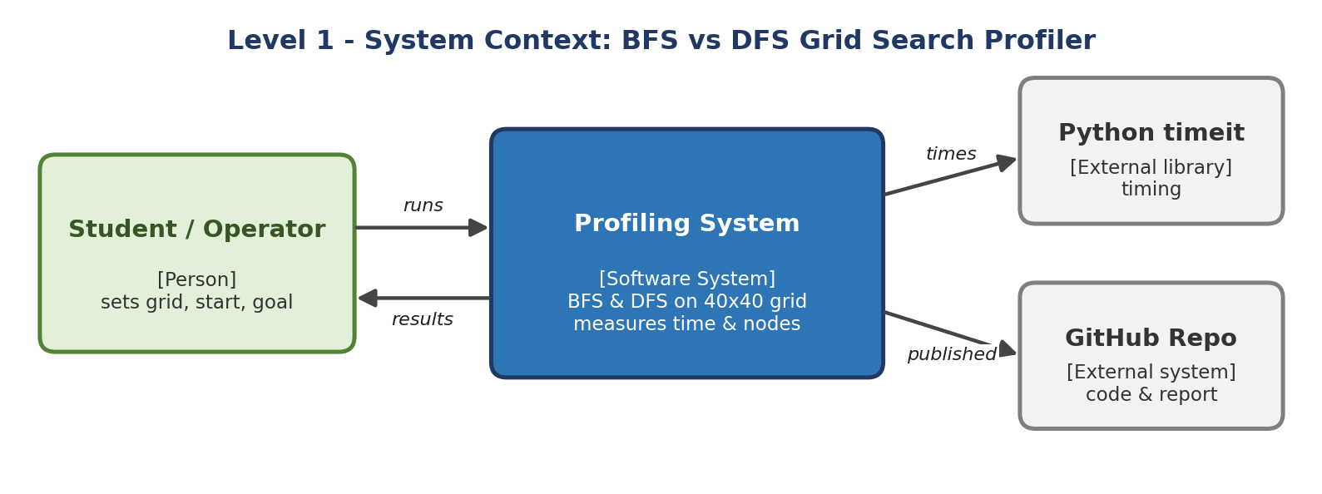
The Student/Operator is the only user. They configure the grid, start and goal and run the program. The system searches the grid with both algorithms and returns a results table. Python’s timeit library is used as an external tool for timing, and the code and report are published on GitHub.
3. Container Diagram (Level 2)
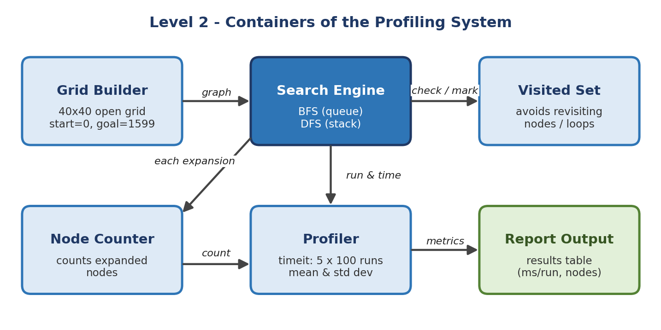
- Grid Builder: creates the 40 x 40 open grid as a graph with node IDs 0–1599.
- Search Engine: runs BFS (queue) or DFS (stack) from start to goal on the same graph.
- Visited Set: remembers visited nodes so no node is expanded twice and loops are avoided.
- Node Counter: increments a manual counter every time a node is expanded.
- Profiler: wraps the search with timeit (5 x 100 runs) and computes mean and standard deviation.
- Report Output: presents runtime and nodes-expanded results for BFS and DFS as a table.
4. Component Diagram (Level 3)
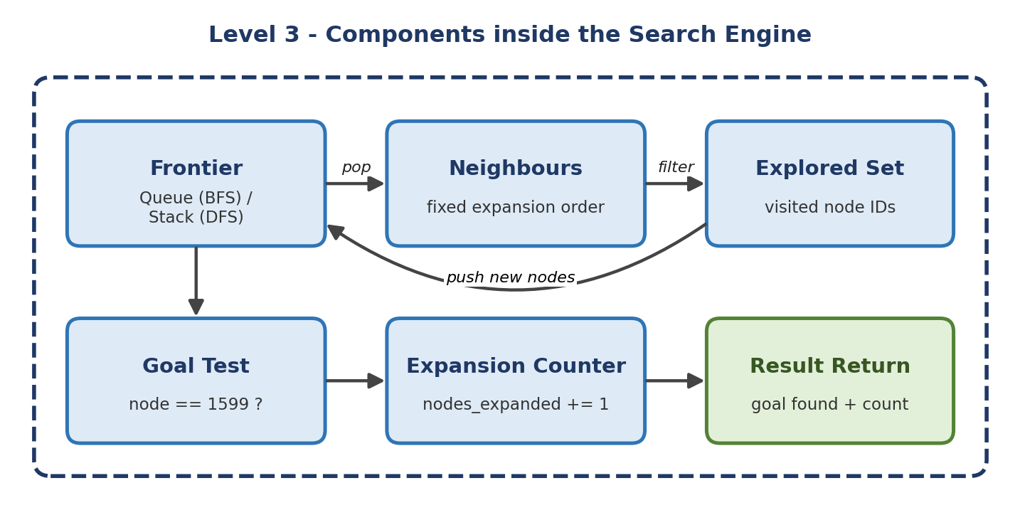
The Search Engine is the most important container, so only it is broken down. The Frontier holds nodes waiting to be expanded – a queue for BFS and a stack for DFS; this is the only part that makes the two algorithms differ. The Neighbours component generates adjacent cells in a fixed order, and the Explored Set filters out visited ones. The Goal Test checks for node 1599, and the Expansion Counter records each expansion before the result is returned.
5. Code Level Overview (Level 4)
- class Grid / build_grid(n): builds the n x n grid graph and gives each node its neighbours.
- def bfs(graph, start, goal): queue-based search; returns result and nodes expanded.
- def dfs(graph, start, goal): stack-based search; returns result and nodes expanded.
- visited (set): stores explored node IDs inside both search functions.
- expanded (counter): counts expansions per run.
- def profile(func, repeat=5, number=100): timeit wrapper; returns mean and std dev in ms/run.
- def main(): builds the grid, profiles both algorithms and prints the results table.
6. Design Decisions
I separated the Grid Builder, Search Engine and Profiler so that both algorithms run on exactly the same graph and neighbour order, which keeps the comparison fair. Profiling is kept outside the search code so that measurement does not change algorithm logic. A manual counter was chosen for nodes expanded because timeit only measures time. The Frontier is the single point of difference between BFS and DFS, which keeps the design simple and easy to extend with A* later.
7. AI Contribution Note
- AI tools used: Claude (Anthropic) was used.
- What AI helped with: understanding the C4 model requirements, suggesting the container/component breakdown, drafting the diagrams and structuring this report.
- What I did myself: chose the BFS-vs-DFS system from SLE-2, ran the experiments, reviewed the diagrams against my own code, and checked that the design matches what I implemented.
8. Conclusion
Using all four C4 levels, I described the same BFS/DFS profiling system from the outside world down to its functions. Context showed who and what interacts with the system, Container showed its main blocks, Component showed the internals of the Search Engine, and Code listed the main functions. I learned that a layered view makes the design easier to explain, and that separating search, profiling and output keeps each part simple and reusable.

